[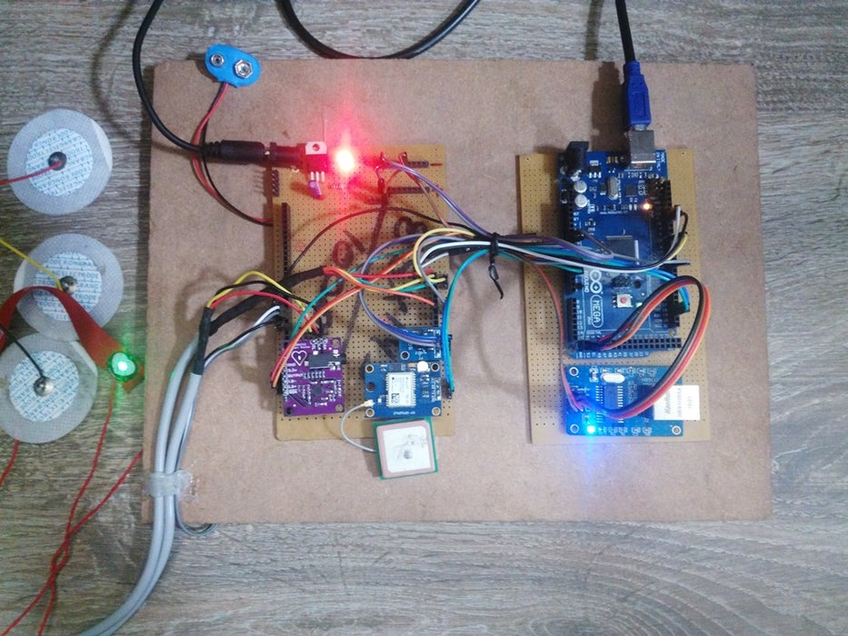](https://content.instructables.com/FF6/FWUC/IUKETU1N/FF6FWUCIUKETU1N.jpg?auto=webp&frame=1&fit=bounds&md=c42abb4e2ce927dc3c87c9947e2f6194)

[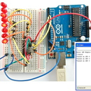](https://www.instructables.com/HOW-TO-GET-HEX-FILE-FROM-ARDUINO-/)

[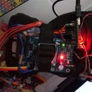](https://www.instructables.com/HandTalk-2-a-Smart-Hand-Glove-Intrepreter/)

[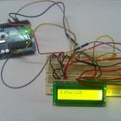](https://www.instructables.com/Interfacing-of-LCD-With-Arduino-Uno-by-Using-Only-/)

According to research, we found that approximately 2000 people died monthly due to the only carelessness of their health. This is because they don‟t have time for themselves and forget about their health management due to a heavy workload. The reason behind to make this project is the growing world of technology and people forget their health checkup which is needed to be done monthly or quarterly. As we all know that internet of things make our life easier. So, we have decided to make an internet of things based healthcare project for people who provide them all the personal information about their health on their mobile and they can check their all historical health data. The best part of this project is that it can be used by everyone and make our health management easier than available systems. Android applications help a person to access the piece of information anytime anywhere in the mobile only and it is easy to carry a mobile. It will save a lot of money of user which is going to be spent on curing of any disease, by giving early warning of health disorder.

The IOT Based Health Care System for the Elderly is cheapest healthcare device based on the IOT platform for the patients and doctors. It provides a solution for measurement of body parameters like ECG, Temperature, Moisture, and Heartbeat. It also detects the body condition and location of the patients. The mobile application for the patient and doctors contain a very simple GUI Interface for reading all the parameters in the mobile or at anywhere in the world by using internet connectivity. In this project we are using various sensors and modules for performing a different type of functions and the „Thingspeak‟ Cloud service is used for storing all the data in the cloud, it provides security and facility of accessing all the parameters at any time which is very useful for the doctors at the time of treatment. This system also generates an alert when it required that means at the time of any critical conditions and notifications about the medicines, location change, conditions etc.

**Step 1: Background Theory**

[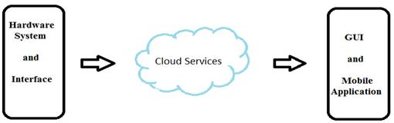](https://content.instructables.com/FYD/W42Z/IUKETT86/FYDW42ZIUKETT86.jpg?auto=webp&frame=1&fit=bounds&md=c54022825e21b991ed844a774b8a82b2)

The Technology behind this project is IOT (Internet ofThings).The above fig. shows basic block diagram shows working of Internet of Things based systems where hardware system contains sensor measure the respective parameters, controllers, required modules which further processed and upload the collected data to the cloud. In the second part, cloud service provider is selected which give us a service to store our data and access it over mobile application/website. In the third part, uploaded data is fetched on an android application which provides a friendly graphical user interphase help the person to access his/her monitored health data.

**Step 2: Hardware & Software Requirements:**

**Hardware Components:**

1) Arduino Mega 2560

2) Temperature Sensor (DS18B20)

3) Humidity Sensor (DHT11)

4) Accelerometer (ADXL335)

5) ECG Module (AD8232)

6) Ethernet Shield (R911105A)

7) GPS Module (NEO-6M)

8) Resistors

9) Capacitors

10) IC 7805

11) Electrode Pads

12) Connecting Wires

**Software Requirements:**

1)Arduino IDE

2)Android Studio

**Language Used:**

1)Embedded C

2)JAVA

3) XML

**Step 3: Circuitry and Working:**

[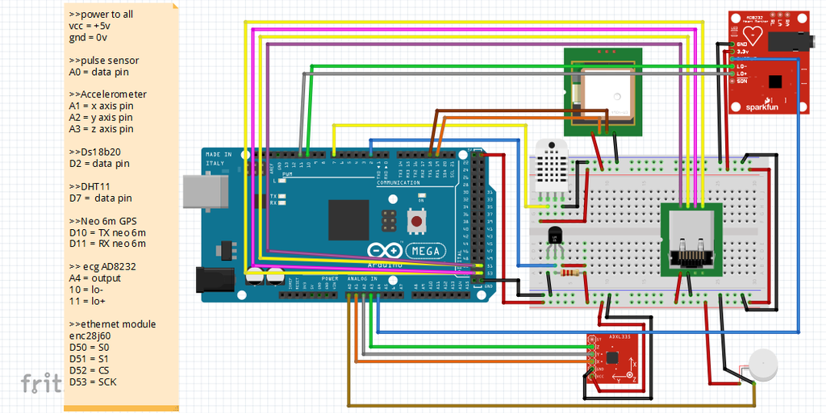](https://content.instructables.com/FK8/3G55/IUKETPTH/FK83G55IUKETPTH.png?auto=webp&frame=1&width=1024&fit=bounds&md=55fa24f9e03794871471317d7b65fae4)

In this, we have used Arduino mega as microcontroller unit.All the components and modules are connected as give in a circuit diagram.

For this system we required two types of power supply 5V or 3.3 V because of some components are operated in 3.3 V.All the sensors,which generates the analog output is connected to an analog pin of Arduino's analog pins.And Digital sensors like(Temp.,Humidity) there are connected to digital pins.The Ethernet Shield (HANRUN) is used in this system for internet connectivity.It can be replaced by GSM or Wi-Fi module also.

The analog/digital data are processed by arduino and with the help of internet connectivity all the monitered data sended to the cloud (Here we have used ThingsSpeak).ThingSpeak cloud provieds the MATLAB Visualization or MaATLAB Code.By this we can plot graph and geting desriable data.

We have also developed Ardoride app for Visulaization of data to others.All data from cloud are avilable into mobile app.This mobile app also genrates alerts when required.

**Step 4: Introduction of Cloud:**

**Cloud computing:**

Cloud computing, also known as on-the-line computing, is a kind of Internet-based computing that provides shared processing resources and data to computers and other devices on demand. It is a model for enabling ubiquitous, on-demand access to a shared pool of configurable computing resources (e.g., networks, servers, storage, applications and services), which can be rapidly provisioned and released with minimal management effort. Cloud computing and storage solutions provide users and enterprises with various capabilities to store and process their data in third-party data centers. It relies on sharing of resources to achieve coherence and economy of scale, similar to a utility (like the electricity grid) over a network.

**Cloud storage:**

Cloud storage is a model of data storage in which the digital data is stored in logical pools, the physical storage spans multiple servers (and often locations), and the physical environment is typically owned and managed by a hosting company. These cloud storage providers are responsible for keeping the data available and accessible, and the physical environment protected and running. People and organizations buy or lease storage capacity from the providers to store user, organization, or application data.

* https://thingspeak.com
* Send sensor data to the cloud

**ThingSpeak Channel:**

Channels store all the data that a ThingSpeak application collects. Each channel includes eight fields that can hold any type of data, plus three fields for location data and one for status data. Once we collect data in a channel, we can use ThingSpeak apps to analyze and visualize it.

**Step 5: Channel Setting of Cloud**

**Channel Settings**

· Channel Name: Enter a unique name for the ThingSpeak channel.

· Description: Enter a description of the ThingSpeak channel.

· Field#: Check the box to enable the field, and enter a field name. Each ThingSpeak channel can have up to 8 fields.

· Metadata: Enter information about channel data, including JSON, XML, or CSV data.

· Tags: Enter keywords that identify the channel. Separate tags with commas.

· Latitude: Specify the position of the sensor or thing that collects data in decimal degrees. For example, the latitude of the city of London is 51.5072.

· Longitude: Specify the position of the sensor or thing that collects data in decimal degrees. For example, the longitude of the city of London is -0.1275.

· Elevation: Specify the position of the sensor or thing that collects data in meters. For example, the elevation of the city of London is 35.052.

· Make Public: If you want to make the channel publicly available, check this box.

· URL: If you have a website that contains information about your ThingSpeak channel, specify the URL.

· Video ID: If you have a YouTube™ or Vimeo® video that displays your channel information, specify the full path of the video URL.

**Using the Channel**

We can get data into a channel from a device, website, or another ThingsSpeak channel. You can then visualize data and transform it using ThingSpeak Apps.

ü Channel detail:-

Channel name-Health care system

Channel ID: 125XXX

Author: acd@gmail.com

Access: Private, Public

**Step 6: Matlab Analysis or Alerts:**

[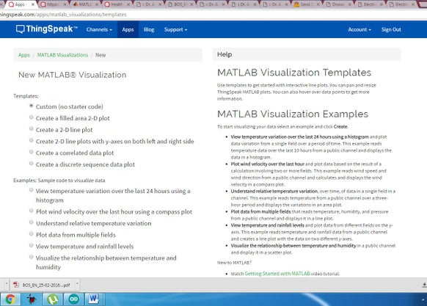](https://content.instructables.com/FC5/6ORX/IUKETPU4/FC56ORXIUKETPU4.jpg?auto=webp&frame=1&width=1024&fit=bounds&md=50fc447ddd4561f9ad5244fed12f29d2)

[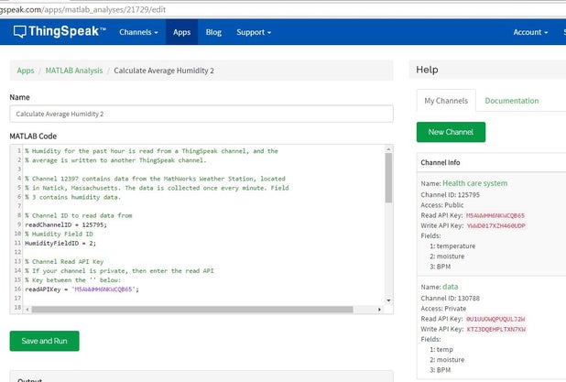](https://content.instructables.com/FQ2/55IQ/IUKETPWH/FQ255IQIUKETPWH.jpg?auto=webp&frame=1&width=1024&fit=bounds&md=7f9be210bff464653a0294bf46e1594d)

**In ThinkSpeak Cloud we can analyze the data or use it for another process.And we can also generates the twits or alerts from it.**

**MATLAB Analysis**

• Explore data collected in a channel or scraped from a website

• Find and remove bad data

1. Convert data to different units
2. Calculate new data
3. Build data models

After analysis, we can write data to the channel or publish it to share our results.

**Time control**

Use the TimeControl app to trigger an action at a specified time. We can set up TimeControl to run MATLAB® code, send ThingTweet statuses, add new TalkBack commands, or send ThingHTTP requests.

1. Time control setting

* Name: Enter a unique name for this TimeControl.

• Time Zone: The time zone is based on our account settings. To change this, click edit.

• Frequency: Choose whether the TimeControl runs once or at recurring intervals.

• Recurrence: Choose a recurrence pattern:

a)Week: Every weekday specified o Day: At a specified time daily

b)Hour: At a specified hourly interval

c)Minute: At a specified minute interval

• Time: Enter the time at which the TimeControl runs.

• Fuzzy Time: Enter a random number of minutes around a scheduled time for the TimeControl to run.

• Action: Select the action to trigger when the specified parameters are met.

**MATLAB Analysis is used in this project for generating alerts or twitter twits by the think speak.**

**Step 7: ​ANDROID APPLICATION AND ITS FUNCTIONALITY**

[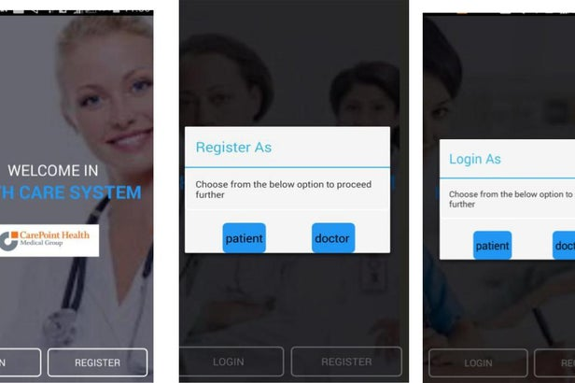](https://content.instructables.com/F68/IN78/IUKETQX2/F68IN78IUKETQX2.jpg?auto=webp&frame=1&width=1024&fit=bounds&md=b3f135e2239822fc349e2c996b78f2ba)

[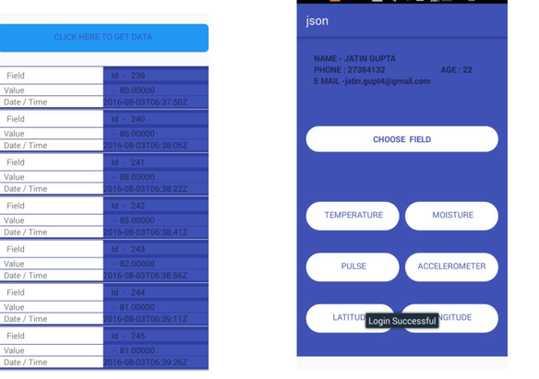](https://content.instructables.com/FY0/M1JB/IUKETQQM/FY0M1JBIUKETQQM.jpg?auto=webp&frame=1&width=1024&fit=bounds&md=b2398603dcfba22613ffdfac039e7011)

**Application Working**

· This application can be used by DOCTORS and PATIENTS:

***Doctor***

In the application, doctor can register themselves with their personal information of their clinic, address, field, etc. and consists of a unique doctor id through application after registration. It can check the status of their entire registered patient in the app. Status means the data of every single patient which is connected to that particular doctor. Each doctor can have multiple patients and every patient has their own unique patient id. This unique id will help doctor and patient to connect with them and doctor can track or check the record of every patient.

***Patient***

Patient will be provided with the unique id and password while registration of hardware device. Patient will able to see their al personal details and their all data of different fields in the app. This will consists of all historical data till the present date which can be filter according to their requirements. Patient can anytime view their health status data of different field anywhere anytime.

***Login Credentials:***

Doctor:

Doctor will require 2 credentials for login:

· Doctor Id

· Password Patient:

Patient will require 2 credentials for login:

· Patient Id

· Password

**Regisration Credentials:**

Doctor:

Doctor need to fill their personal details like:

· Password, Clinic name, Address, profile, etc.

**User Interface:**

Doctor Interface:

When the doctor will successfully signed in to the app , it will direct to main activity which will consists of navigation drawer and the name of the patient in their main screen.

Navigation Drawer:

(Intro) - The navigation drawer is a panel that displays the app‟s main navigation options on the left edge of the screen. It is hidden most of the time, but is revealed when the user swipes a finger from the left edge of the screen or, while at the top level of the app, the user touches the app icon in the action bar.

In our app, this drawer will consists of the fields which will consists of data at each field respectively. After clicking on any field, the respective data of that field will be displayed to the doctor of a selected patient.

A simple and designed data will be displayed to the doctor in their activity which will consist of all the historical data of every field of every connected patient.

Patient Interface:

After successfully login of patient, it will direct to main screen which will consists of the personal information of a patient and ask for a selection of field to get the data of a particular field.

After selecting the particular field, the all historical data will be shown to the patient on their screen in a design view which will also allow patient to filter the date and time according to their requirements. This data can be share with any of their relatives or family members.

Andoride app is developed by JATIN GUPTA (Application Virtical for this Project)

**Step 8: ​CONCLUSION AND FUTURE ENHANCEMENTS**

**Future enhancements:**

For more reliable and low complexity of the system the controller section can be replaced by other Advanced Microcontrollers.¬

The applications can be added by adding the more modules and sensors.¬

Accuracy can be increased by using high sensitive sensors and more reliable modules.¬

For more security and functionality in the cloud can be increased by using paid clouds or won cloud.¬

Using the X-bee Module we can create a wireless zone and this device may communicate with the other devices also in big hospitals.¬

Ethernet Module can be replaced by Wi-Fi module and GSM module for Internet Connectivity.¬

For simpler GUI we can draw Sketches and Graphs in the Mobile applications.¬

**Conclusion:**

IOT platform provides a simple environment to connect the hardware devices through the cloud and users. Then by using IOT we can make any type of devices by different type of sensors and modules.¬

This project is useful for Patient who required regular check the parameters.¬

The previous data storage facility provides to the doctors to better treatment environment by this friendly device.¬

The simpler working and Mobile app GUI provides the friendly connection between the devices to users.¬

As device also provides the location updates, body condition status and medicine alerts, it is very useful for take care the patients by doctors and relatives.¬

Finally we can say, this is a complete healthcare device.¬

**Step 9: About Project Team :**

This project had completed during our summer internship 2016 under the CONSORTIUM FOR INNOVATION,DELHI,INDIA.

For Completion this project there are different verticals from each domain:

Team Members:

1) Sachin Kr. Verma (Hardware Vertical)

Student - ECE,Dronacharya Group of Institutions,Gr. Noida

Mobile: +919015238515 ,Mail: vsachin094@gmail.com

Role: Reseach Work,Hardware Simulation,PCB Design,Testing

2)Saurabh Jiwal (Coding Vertical)

Student -ECE,Dronacharya Group of Institutions,Gr, Noida

Role: Coding,Cloud Connectivity,Testing Software

3) Jatin Gupta (Mobile App Vertical)

Student-CSE,DGI,Gr. Noida

Role: Mobile app development,Research work